Initial ERD:

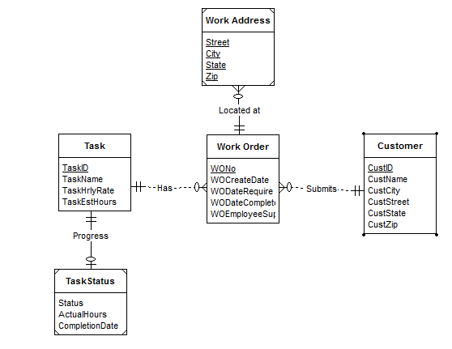

The Customer, Work Order and Task entities follow from the narrative.

Weak entities Work Address and Task Status help to specify additional information about each Work Order and Task, respectively. Identifying relationships are used to connect these weak entities.

Each Work order has one customer although a customer may specify multiple work orders so there is a M-1 relationship to connect Work Orders to customers.

Since a single task may satisfy multiple work orders, there is a 1-M relationship from Task to Work Order entities. There is a weak entity named Task Status which connects to each Task via an identifying relationship.

Revised ERD:

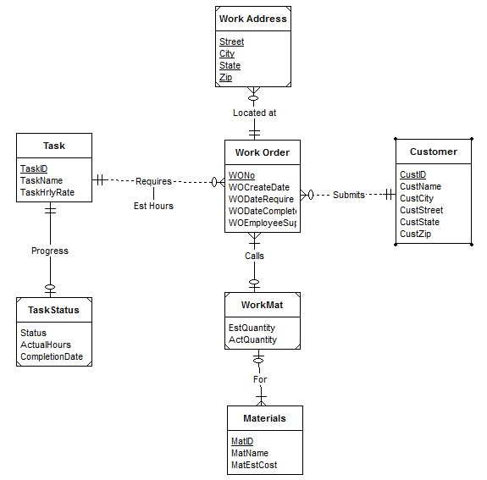

Refinements:

1. The additional entity, Materials has been added which connects to Work Orders indirectly via the weak entity WorkMat (with Quantity attributes relating to materials) and identifying relationships.
2. Because the estimated number of hours for a task depends both on the work order and task, the relationship is changed to “Requires” connecting Task and Work Orders to include the attribute of ‘Est Hours’.